
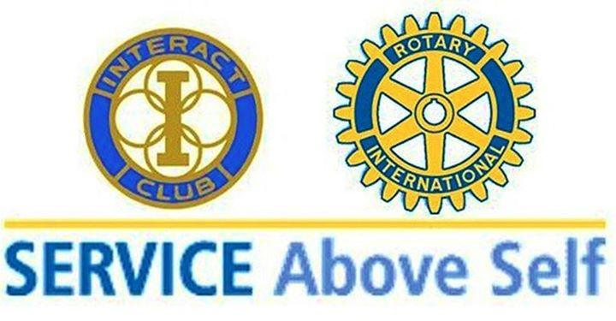

starts Wed, October 7th
TEAMS meeting
Communicate through Remind 1st:
REMIND -to: 81010
message: @1st3rdwed
Earn Volunteer Hours soon!
Sponsor: Mrs. Vaughn A18

